Physics Unit 1 Test Graphs, Vectors and Scientific method
Breakdown of questions : 5% of points on scientific method, 25 % on vectors which includes 1 of 2 free response questions and 70 % on motion graphs which includes 1 of the 2 free response questions.
Scientific method – Identify from a description the independent and dependent variables.
Vectors – Distinguish between scalar and vector quantities
- If an object moves 3 km west and then 5 km east what is the final displacement?

- Two forces act on an object – one at 20 N going south and the other at 30 N going south – the resultant force vector is ?

- A hiker goes 23 km north then 57 km east then turns 90 degrees and goes 23 km south and one more 90 degree turn for 57 km west. The final displacement of the hiker is –

- Add the following vectors 5 m east , 10 meters south and 18 meters west. The resultant should have units and direction.

Motion Graphs –
Type of graph | Slope means  _________ | Horizontal line  Means __________ | Area under line  ___________ | Linear /curved  slope
Position/time
Velocity /time

Some last graphs to practice on –
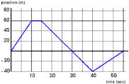

This one was also in the notes :
- At what time is the object at rest ?

- When is the car traveling fastest in a positive direction? in a negative direction ?

- When does the car travel the greatest distance at a constant velocity?

- What is the object’s displacement?

Velocity time graph
Also from the last set of notes …
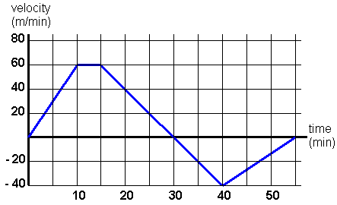

- When does the object travel in a negative direction ?

- When does the object stop?

- What is the acceleration between 0 and 10 seconds and between 15 and 40 seconds ?

- What is the distance traveled between 15 and 40 seconds and what is the displacement between 15 and 40 seconds. ?

- What is the speed and velocity between 15 and 40 seconds ?

